REGISTRARS’ ASSOCIATION OF NEW JERSEY

CLAIMANT’S CERTIFICATION AND DECLARATION

I do solemnly declare and certify under the penalties of the law that this invoice is correct in all particulars, the articles have been furnished or services rendered as stated herein, that no bonus has been given or received by any person or persons within the knowledge of this claimant in connection with the above claim and that the amount charged is a reasonable one.
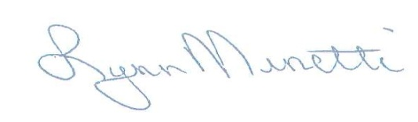
Lynn Minetti, President
Tax ID#22-3100203

PLEASE NOTE: You do not need to send us a Purchase Order/Voucher for a separate signature since the pre-signed certification above can be attached to your PO/Voucher in lieu of sending it to us for a signature. This form of certification performance of services has been determined by the Local Finance Board to meet the requirements of the Statutes for this type of expenditure.

Please make checks Payable to: New Jersey Registrars’ Association

PLEASE MAIL YOUR CHECKS TO:

NEW JERSEY REGISTRARS’ ASSOCIATION
c/o: Maryann Orapello, H.O.
Wayne Health Department
475 Valley Road
Wayne, NJ 07470

